**Steps to Add, Edit and Delete the Custom Post From Admin Panel:-**

1. Custom Post Name we are created is News Posts as shown in screenshot.

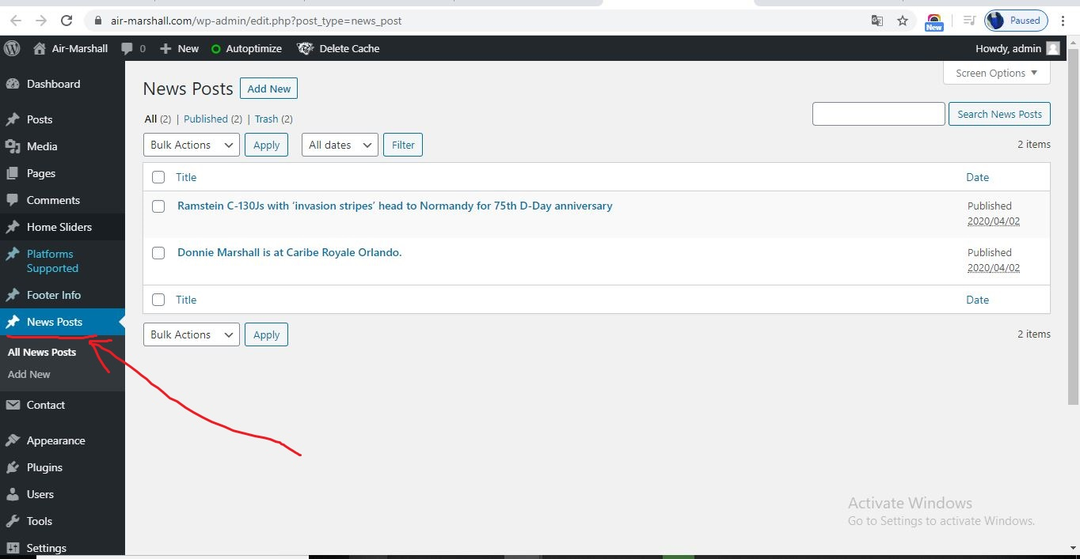

1. There are two options:- **All News Posts** and **Add new.**
2. **All News Posts** show all post that we have created. And **Add New** option is used to add New Post.
3. See the following screenshot, here, we have option:- **Edit** option for edit the Post.

And **Trash** for Delete the Post :-

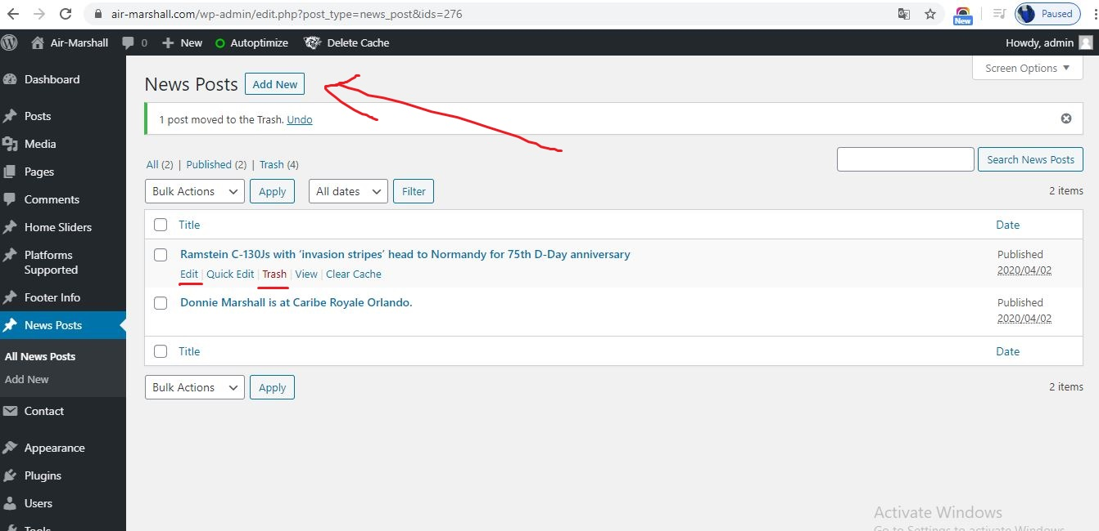

1. Click on **Edit** Option, following window is opened, here we can change the text:- Like **Heading**, **Paragraph** and **Image**.

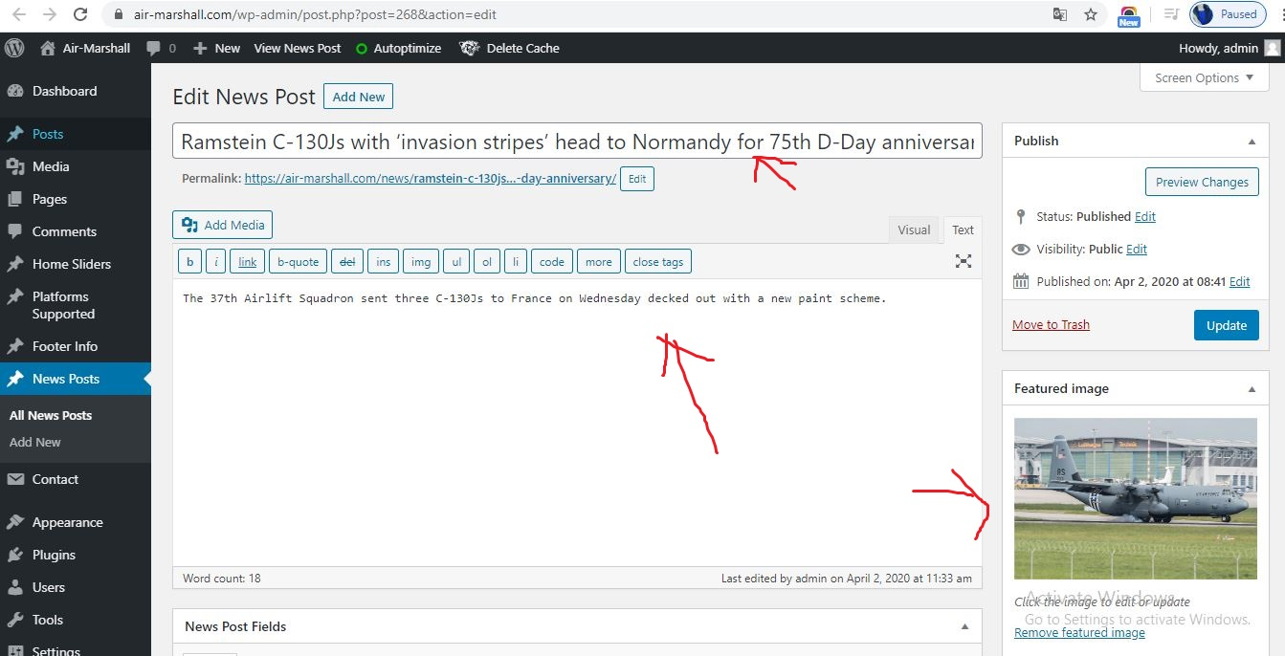

1. Click on **Update** Button, when we have done the changes. Shown on following :-

